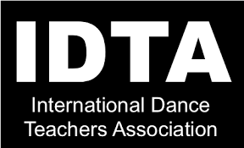
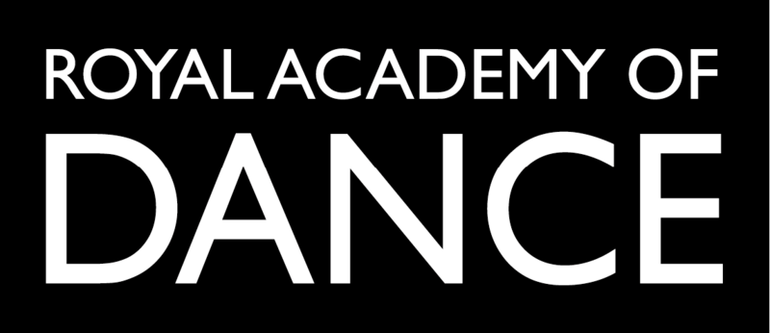
Art Of Dance

We invite your child to attend the Art Of Dance Easter camp at BISHOP HANNINGTON COMMUNITY CENTRE, 38 HOLMES AVENUE, HOVE, BN3 7LD.

Tuesday 4th, Wednesday 5th and Thursday 6th April 2023
The fee, which includes the three days, is £120 per child.

Classes will include drama, modern, ballet, flamenco, street dance, mime and Bollywood dance. This will provide many opportunities for your child to develop their performing arts skills, make new friends and enhance their confidence.

For enquiries contact Michelle Wilson on 0797 606 8989
www.artofdance.co.uk
……………………………………………………………………….

Booking form

Name of child………………………………………………..Age………….
Emergency contact number………………………………………………..
Medical conditions…………………………………………………………...

Dance abilities and experience……………………………………………..

I give permission for the above named child to appear in public displays of dancing, and I acknowledge that these may be photographed for private or publicity purposes.

I enclose 50% deposit (£60) and understand the remaining £60 is payable by 1st April 2023.

ONLINE PAYMENT; Santander business account
ART OF DANCE 43002637 SORT 09.06.66

